Summer Transition Work Mathematics

Task:
After the summer holidays you will be sitting a suitability assessment based on topics which you need to be fully fluent in. There will be an expected pass mark of 50%. Here are some practice questions on some topics along with a list of topics that will also be on the test provided with Maths Watch clips where there are further practice questions for you to try.
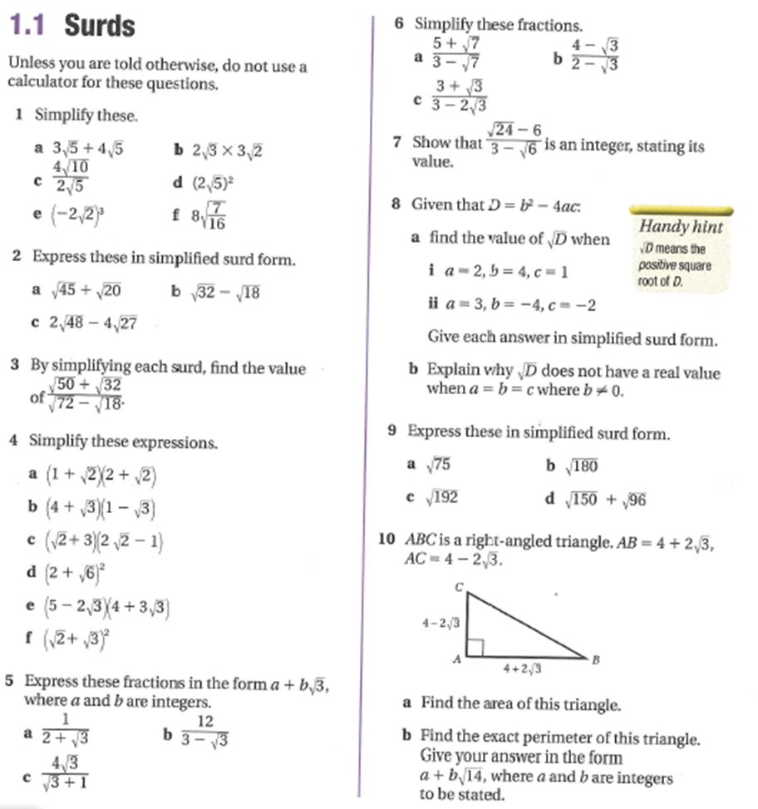

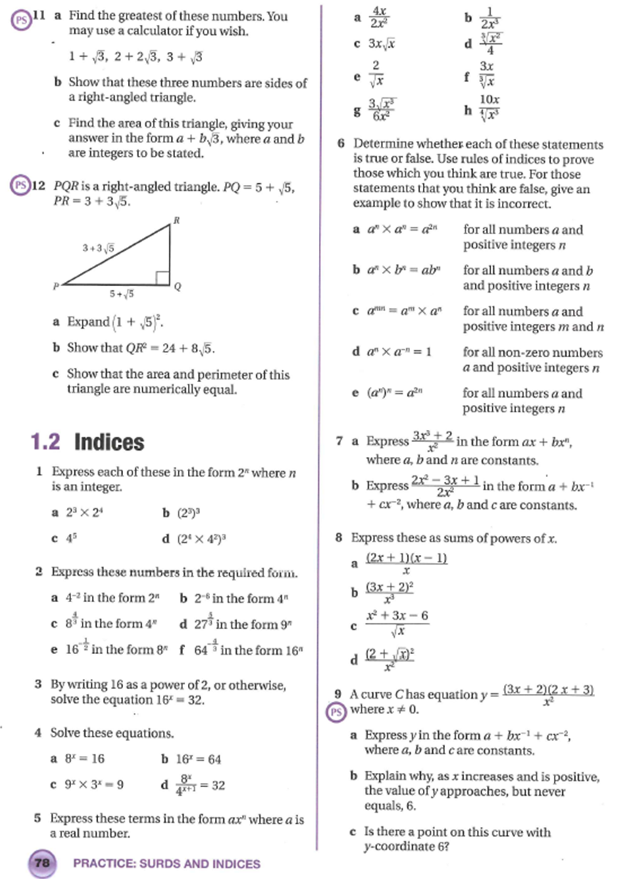
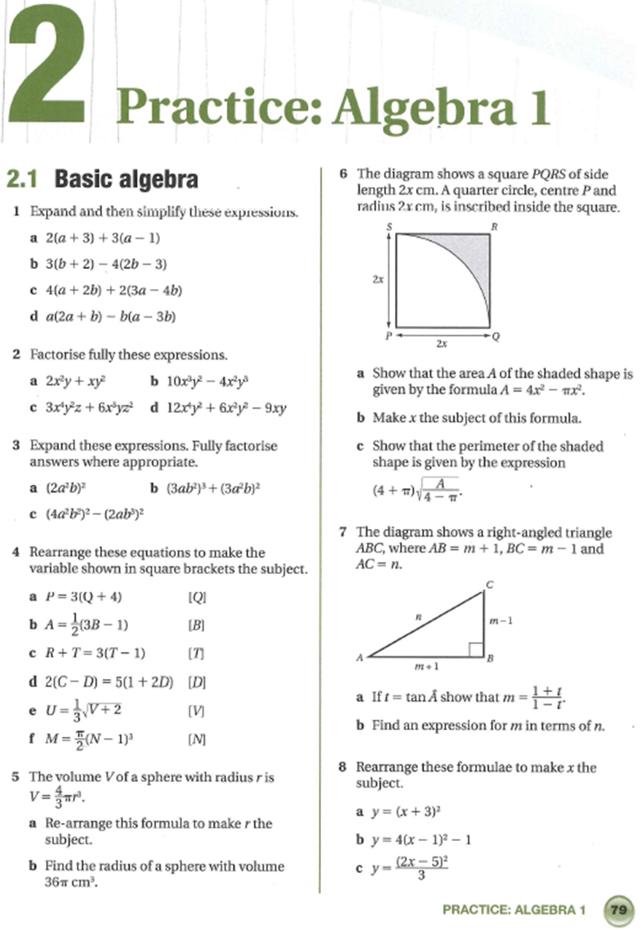

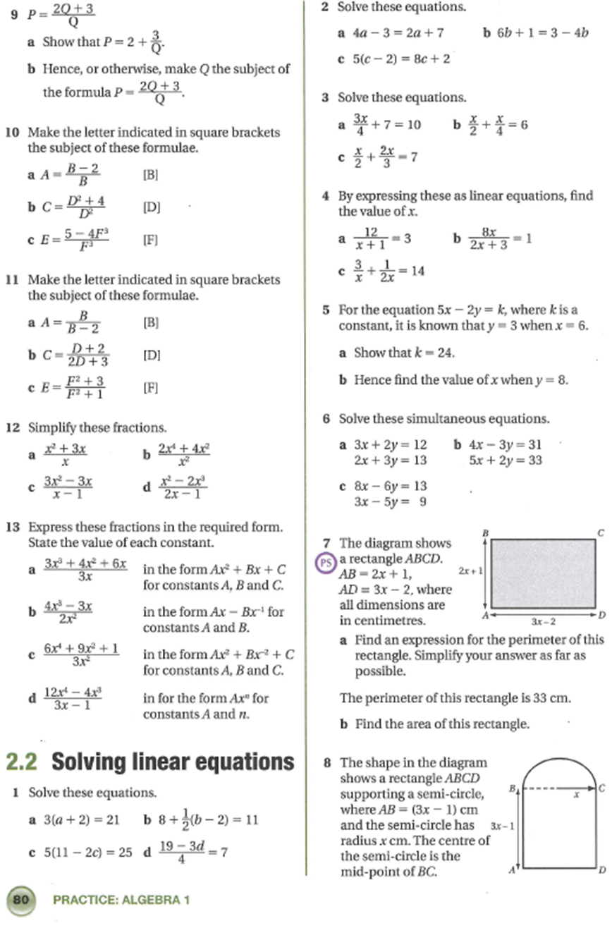
Coordinate Geometry: Interpreting Graphs and Equations of Lines
GCSE Clips - Clip 96 and 140
Transformations of Graphs
GCSE Clips – Clip 196a
Arcs and Sectors
GCSE Clips – Clip 167
Trigonometry
GCSE Clips – Clip 201, 202, 203
Vectors
GCSE Clips – Clip 174, 219
Quadratics and Functions
AS level Clips - QF 4: The Discriminant
Simple Differentiation and Integration
AS Level Clips – D1 – D8, I1 – I8

All of the clips can be found using Maths Watch. All of the GCSE clips have interactive questions and worksheets attached to them at the top of the clip, as shown below. All of the AS level clips have practise questions within the video.
