Summer Transition Work History
Task:

Write an essay on the following topic:
How far was the political landscape in the period 1918 to 1939 transformed by the Representation of the People Act 1918?
Total Marks = 20
You should write your essay in continuous prose.
Your essay will be marked for its:
• Analytical focus
• Accurate detail
• Supported judgement
• Argument and structure

Please see the mark scheme below:
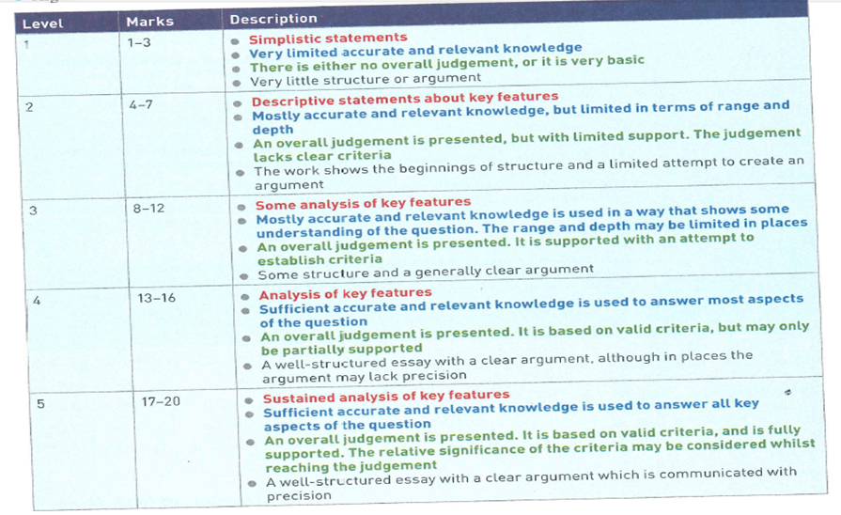

Hints
1. What was the Representation of the People Act 1918 and how did it change the political landscape?
2. What was the political situation like in 1918?
3. How had the political situation changed by 1939?
4. What else/ other factors changed the political landscape – Rise of Labour, split in the Liberal party (Asquith vs Lloyd George), the Campbell affair and the Zinoviev letter
5. Make sure you stick to the time period – 1918-39

If you want any more help on this, please find/ email one of the following history teachers. Miss Penny cpenny@tscacademy.org.uk , Mr Player jplayer@tscacademy.org.uk , Mr Hall mhall@tscacademy.org.uk or Mrs Salisbury hsalisbury@tscacademy.org.uk

