Summer Transition Work French
Write an essay on the following topic:
Comment la technologie fait partie de la vie quotidien? (How is technology part of everyday life?)

You should write your essay in continuous prose in French.
Your essay will be marked for the accuracy of your language and grammar.
The maximum number of marks that can be awarded is: 20 (see below)
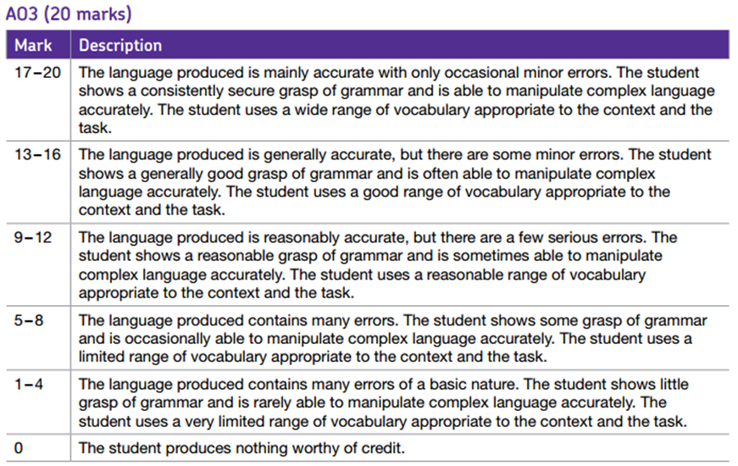

Hints
- Describe what technology is used
- Explain what you use it for
- Give opinions and reasons
- Use ON for verbs (to mean we or you or people in general…)

Resources:
- You can use any of your French exercise books/notes from GCSE.
- You may use dictionaries but only for single words.
X You must NOT use google-translate or similar – translating phrases or sentences will NOT show your abilities.

