Summer Transition Work Accounting

A Level Accounting Transition Work
Patisserie Valerie is a chain of cafés that operates in the United Kingdom. The chain specialises in cakes, and its menu included continental breakfasts, lunches and teas and coffees. The company went into administration in January 2019, prior to a management buyout.
Your transition work is to investigate the circumstances that led to the failure of this established business.
Part 1: The Accounts:
You have a copy of an interim financial report for Patisserie Valerie from 2018. You should use this to comment on the apparent financial position of the company at that time. Some suggestions for items you could look for:
- Gross profit
- Net cash
- Dividends
- Revenue growth
Part 2: The Deception:
Read the 2 news articles about the decline of Patisserie Valerie. Can you find and comment on the items in their accounts that are referred to in the news story? Try to find and comment on at least 3 items from the news stories.
E.g. In the article it states…
“When the scandal was first revealed, Patisserie Valerie said an initial investigation of its accounts showed that instead of having £28m in the bank, it was nearly £10m in debt.”
This would mean that the business accounts would show the business as being worth more than it is actually worth. This deceives investors, shareholders, employees and even board members about the financial health of the company.
Part 3: Ethics:
Read the Code of Ethics for Accountants, particularly the ‘Fundamental Principles’ section. (https://www.ethicsboard.org/system/files/uploads/IESBA/IESBA-Fact-Sheet.pdf)
Summarise which of the 5 principles you believe have been broken by whoever produced the accounts for Patisserie Valerie. Extension: Why do you think these principles exist? What happens if they are broken?

Patisserie Valerie says its accounts were 'significantly manipulated'
Cafe chain says it has uncovered thousands of false entries in its ledgers
Sarah Butler
Wed 16 Jan 2019 18.36
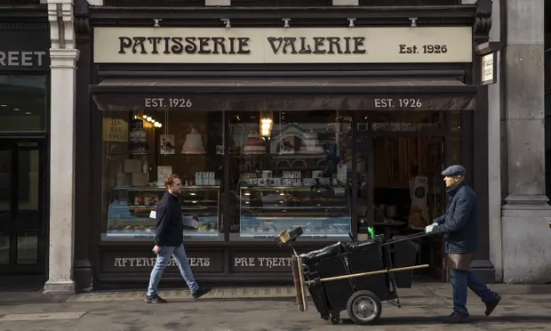

Patisserie Valerie operates 200 cafes and employs 3,000 staff. Photograph: Dan Kitwood/Getty Images
Patisserie Valerie, the cafe chain which came within hours of financial collapse in October after discovering a multimillion-pound gap in its accounts, has uncovered “thousands of false entries into the company’s ledgers”.
In a statement to the Stock Exchange, the company, which operates 200 cafes and employs 3,000 staff, said work carried out by forensic accountants had revealed that “the misstatement of its accounts was extensive, involving very significant manipulation of the balance sheet and profit and loss accounts”.
The company said it was now clear that the cash flow and profitability of the business had been overstated in the past and was “materially below” the numbers the company provided when the accounting black hole first emerged in October.
Luke Johnson, the multimillionaire chairman of the business, was forced toput £20m of his own money into the firm to keep it afloat after the uncovering of potentially fraudulent accounting irregularities that left it teetering on the brink. Other shareholders later put up £15m, £10m of which was used to pay back half of Johnson’s loan.
The company was valued at £450m when the problem was uncovered, but the shares were suspended and have yet to restart trading.
The company’s finance director, Chris Marsh, was arrested by Hertfordshire police, bailed and resigned.
The Serious Fraud Office has confirmed that it has opened a criminal investigation into an individual but has not given further information.
The Financial Reporting Council is meanwhile investigating accountancy firm Grant Thornton for its role as auditor to Patisserie Valerie.
The group’s chief executive, Paul May, resigned in November and was replaced by Steve Francis, a turnaround expert who previously ran the pork producer Tulip. Only Johnson and the deputy chairman, Lee Ginsberg, remain of the original board.
On Wednesday, the company said it had hired accountants KPMG in an attempt “to preserve value for its stakeholders going forward”.
It is understood that a number of options are being considered. However, KPMG is known for its expertise in restructuring and insolvency, particularly a procedure known as a company voluntary arrangement. CVAs enable businesses to renegotiate rental agreements with landlords or close stores.
They have been used by a string of casual dining chains, including Carluccio’s, Byron and Jamie’s Italian, to reduce their high street presence amid a slowdown in consumer spending in an oversaturated market.
Patisserie Valerie was granted a standstill of its banking facilities until this Friday, protecting it from action to recover debts, and is in talks with its lenders to extend the agreement. The company has previously said it wanted the standstill to last a year.
When the scandal was first revealed, Patisserie Valerie said an initial investigation of its accounts showed that instead of having £28m in the bank, as the company had previously told the City, it was nearly £10m in debt.
In a 12 October statement it said underlying profits might have been only £12m in the year to 19 September, compared with £26m reported a year before. The new update said that £12m was an overestimate.
It added that it would take some time before a reliable trading outlook could be produced.
Johnson has waived his £60,000 salary and pledged to give up some of his other directorships as he tries to turn around the chain.
He remains chair of at least 10 boards including the Almeida theatre in London, the Institute of Cancer Research, the entrepreneurial campaigning group StartUp Britain and a number of companies held by Risk Capital – his investment company. These include , Brighton Palace Pier, Majestic Bingo and the owner of Gail’s bakery chain, Bread Holdings.

Patisserie Valerie reveals stores to close
- 23 January 2019
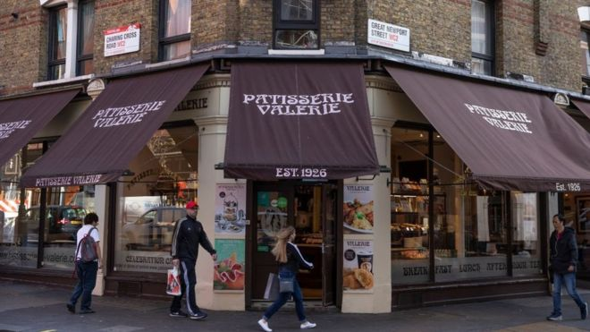
Image copyrightGETTY IMAGES
Administrators of Patisserie Holdings have named the 71 outlets that will close following the firm's collapse.
KPMG said that 902 jobs will go due to the closure of 27 Patisserie Valerie stores, 19 Druckers and 25 Patisserie Valerie concessions.
However, KPMG said it is "business as usual" at the remaining 122 outlets.
The administrator said it was "pleased" with the level of interest it had received from potential buyers of the surviving parts of the business.
Patisserie Valerie was forced into administration on Tuesday after it failed to reach a rescue deal with its banks.
Entrepreneur Luke Johnson, who bought the business in 2006, has committed more money to ensure staff are paid this month.
The first signs of trouble came back in October after accounting "irregularities" were announced. That included "secret overdrafts" unknown to Mr Johnson and the board.
Shares in Patisserie Holdings were suspended and finance director Chris Marsh was arrested and later released on bail without charge.
Mr Johnson, who owned 37% of Patisserie Holdings, kept the business going by extending it a loan, and money was raised from other shareholders.
But earlier this month the company said the accounting scandal was worse than it thought.

Employee reaction: 'I couldn't sleep last night'
A member of staff, who did not want to be identified, told the BBC that Patisserie Valerie's collapse had come as a complete shock to them.
"Apparently everything at work was fine since October.
"I was always asking the managers, 'are you going to close the shop?' and they said no, no, no," said the employee.
"I'm still in shock - I couldn't sleep last night."
Employees of stores that are closing were informed by phone on Tuesday evening, and asked to attend meetings on Wednesday where they will receive further information.
"Last Wednesday, they had a meeting with all the big managers and they were making plans to make the shops better. Everyone was quite positive last week."
Now the company that owns Patisserie Valerie could be facing legal action from investors over the collapse of the cafe chain.
Chris Boxall, co-founder of Fundamental Asset Management, said he was "flabbergasted" by the situation.
He told BBC Radio 4's Today Programme he was considering legal action as he had a "moral duty" to his clients.
Mr Boxall questioned Mr Johnson's oversight of the business.
"What has he and the board been doing? What questions were they asking at meetings, what things were they looking at, did they ever roll up their sleeves and have look at the heart of the business which you would expect from a so-called executive director which he was in this business," he said.
It is not clear if the target of any action might be the company or its former directors, including Mr Johnson.
"This business has gone from half a billion [pounds] valuation to nothing in a matter of months," Mr Boxall said.

'Good brand'
While he had questions for the former directors, he also said there were questions for the banks and the auditors.
"We're very, very angry," he said.
There are hopes the stores which continue trading might find a buyer.
Julie Palmer, regional managing partner at Begbies Traynor, is optimistic. She told BBC Radio 5's Wake Up To Money: "It is a good brand, it has got good High Street presence, it was making good profits over a long period of time.
However, she said potential buyers would be sceptical about the company's figures.
In addition to Patisserie Valerie, the company's other brands include Druckers Vienna Patisserie, Philpotts, Baker & Spice and Flour Power City.

